Different Models used In Design thinking

A.CORE 5-STAGE MODEL (Stanford D School)

The backbone of design thinking comprises:
- Empathise – Understand the user’s needs, pains, and desires.
Example:
Imagine your classmates always lose their stationery. Instead of designing a new pencil box blindly, you observe and interview them. You find out they don’t like carrying big boxes and keep pens in their pockets—which fall out.

Tools: Interviews, shadowing, empathy maps.

- Define – Clearly articulate the real problem. Based on what you found, you write a problem statement.
Example: Not: “They need better pencil boxes.”
But: “Class 12 students need a small, clip-on pen case because carrying big boxes is annoying and leads to lost pens.”

- Ideate – Brainstorm as many creative ideas as possible.
Example: Sketch wacky ideas: a magnetic pen holder for shirt pockets, a foldable pen wrap, or a wristband pen case. Encourage wild thinking before filtering.

- Prototype – Create rough models or mockups of solutions. Create a quick and inexpensive model of your idea. Not the final product—just something to test the concept.
Example :Could be paper, cardboard, even LEGO! For the clip-on pen case, make one with chart paper and Velcro.

- Test – Try the solution, gather feedback, and improve. Give it to real users. Watch how they use it. Get feedback. Learn what fails fast and fix it. If it falls off, back to the drawing board (ideate/prototype/test again). Design Thinking is a loop, not a ladder.

B.IDEO approach

IDEO’s approach to design thinking is a human-centred, creative way of solving problems. It focuses on understanding people’s real needs, coming up with many possible ideas, and then turning the best ideas into practical solutions by testing and improving them.

IDEO’s design thinking = Inspiration (find the problem) → Ideation (think of solutions) → Implementation (make it real).

It’s a 3 Step Approach:
- Start with people → Observe, listen, and learn what they truly need.
- Think creatively → Brainstorm bold ideas without judgment.
- Make it real → Build quick prototypes, test them, and refine until it works in real life.

Example of IDEO’s Design Thinking Approach
- Problem (Inspiration):
Hospitals found that children were terrified of MRI scans. The big machines looked scary, the noise was loud, and kids often had to be sedated.
- Ideas (Ideation):
Instead of focusing only on the machine’s technology, IDEO asked, “How might we make this less frightening for children?”
They brainstormed many playful concepts—like themed rooms, storytelling, costumes, and even “adventure journeys.”
- Solution (Implementation):
They created child-friendly MRI rooms where kids felt like they were astronauts in a spaceship or explorers under the sea.
When tested, children were calmer, sedation rates dropped, and parents were relieved too.
c. Double Diamond Model
- The Double Diamond Model is a design thinking process developed by the UK Design Council. It shows how designers work in two main phases of divergent (broad exploration) and convergent (focused narrowing) thinking.
- It looks like two diamonds side by side:
- Diamond 1 → Understand the problem (Discover + Define).
- Diamond 2 → Create the solution (Develop + Deliver).
- The four steps are:
Discover → Define → Develop → Deliver.

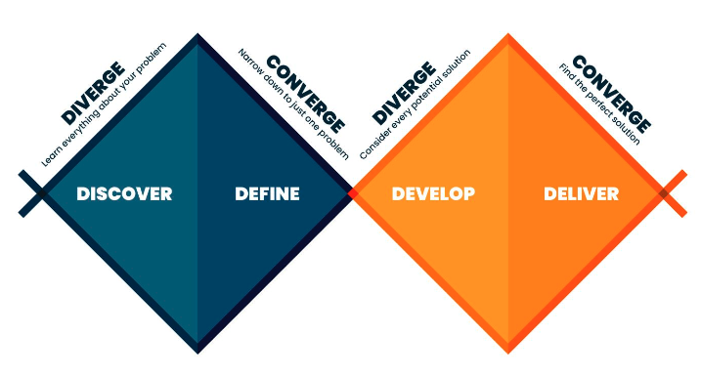

It includes 4 Steps:
1. Discover (Open up)
- Goal: Explore and understand the problem deeply.
- Activities: Research, observation, interviews, user journeys.
- Example: A transport company notices passengers are unhappy. They observe commuters, run surveys, and find the real frustration is not the buses being slow but not knowing when the next bus will arrive.
2. Define (Narrow down)
- Goal: Analyze the findings and clearly define the challenge.
- Activities: Synthesize insights, identify patterns, create problem statements.
Example: Instead of “make buses faster,” they define the problem as:
“How might we help passengers feel informed and less anxious about waiting
3. Develop (Open up again)
- Goal: Generate and test multiple solutions.
- Activities: Brainstorming, prototyping, experimenting, co-creation with users.
- Example: The team creates ideas like mobile apps, digital bus stop displays, or SMS alerts. They quickly prototype and test them with passengers.
4. Deliver (Narrow down and launch)
- Goal: Finalize the best solution, refine it, and implement.
- Activities: Pilots, launch, feedback loops, scaling.
- Example: They launch a real-time bus tracking app. Passengers can now see exact arrival times, reducing stress and improving satisfaction.
- Double Diamond = Explore the problem (Discover + Define) → Create the solution (Develop + Deliver).

D. IBM Enterprise Design Thinking
- IBM’s Enterprise Design Thinking is a framework that helps big teams design products, services, or systems in a way that keeps users at the centre, encourages collaboration, and delivers real outcomes faster.
- It focuses on three core practices:
Hills → Playbacks → Sponsor Users.
1. Hills (Clear Goals)
- Simple meaning:
A Hill is like a target you can see clearly. Instead of a vague instruction like “make this better,” a Hill says exactly who the user is, what they need, and why it helps them.
- It gives the team a shared direction. Everyone knows what success looks like for the user.
- Example:
Not a Hill → “Build a new banking app.”
- A Hill → “A first-time home buyer can get pre-approved for a loan in less than 10 minutes, from their phone.”

2. Playbacks (Open Sharing)
- Simple meaning:
A Playback is like calling everyone together to “play back” what the team has done so far. It’s not a one-time presentation; it’s regular sharing. The goal is to catch mistakes early and keep everyone—from designers to managers to users—on the same page.
- Prevents surprises, avoids wasted work, and ensures feedback is built in from the start.
- Example:
The banking app team designs a prototype of the loan approval flow. Before going further, they hold a Playback with managers, developers, and sponsor users. They show the app screens, gather feedback like “this button is confusing” or “we need extra security here,” and adjust.

3. Sponsor Users (Real Voices)
- Simple meaning:
These are real users who stay involved from the beginning to the end of the project. Not just giving feedback once, but being partners. They make sure the design is useful in the real world—not just in theory.
- Teams sometimes assume they know what users want. Sponsor Users help break those assumptions and bring real-life truth into the design.
- Example:
While building the loan app, the team invites actual first-time home buyers to test prototypes. They notice that users hesitate when uploading documents. The team fixes the process by adding a document checklist and camera upload feature.

